Chettinad college of Engineering and Technology

Department of ECE

Assignment 3

1.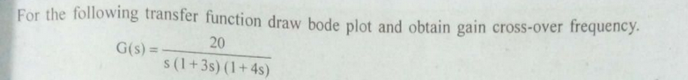

2.